3(a)
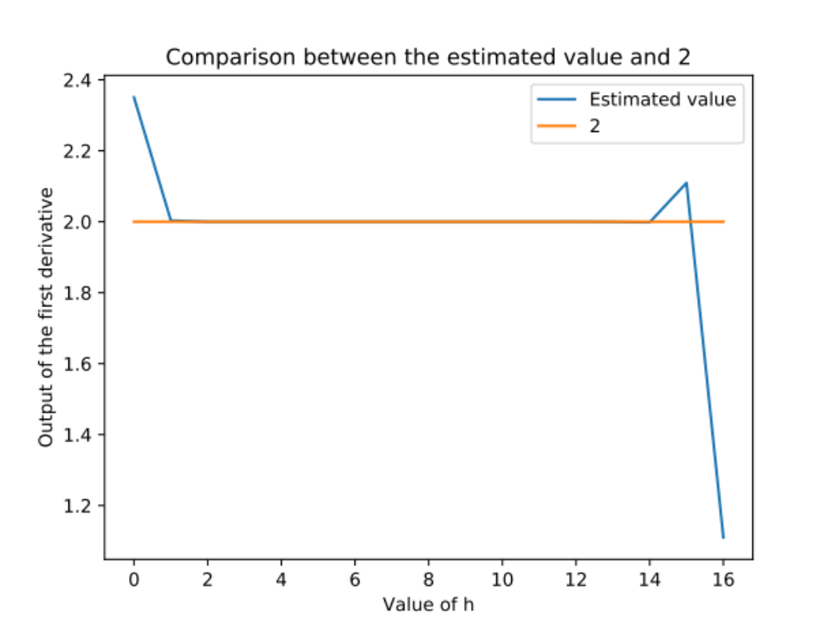
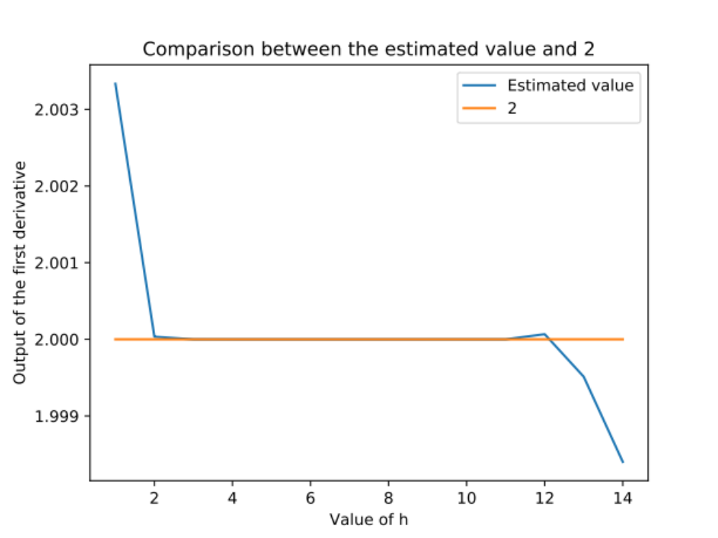
Figure 1 above is the comparison between our estimated values and 2. Notice that the estimated values only close to 2 in the range 1 to 14. Therefore we made a magnified version on h=10**-1 to h=10**-14 as figure 2.
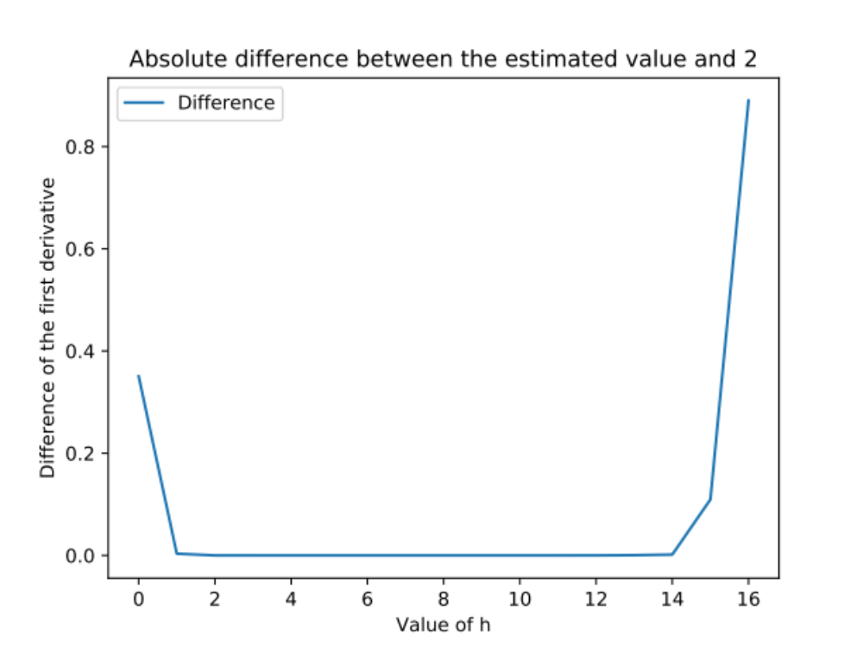
After using python code to find the minimum, we have the minimum is 2.4204638293667813e-11 when h=10 ** -5. Try out the comparison with the error term given in the note,
$$\frac{h^{2}}{3}f^{'''}\left(x\right)=\frac{{\left({10}^{-5}\right)}^{2}}{3}∙8=2.67∙{10}^{-10}$$
which is 10 times larger than the minimum we calculated. Therefore the approximation is quite precise.

3(b)
First of all, we use m = 10, which means that we are taking the 10th derivative and our desire value is 1024. By looking at the result, the Cauchy derivative formula gives us a quite good approximation as 1023.9999999986817. But the evaluation of the step size of central difference is our focus.
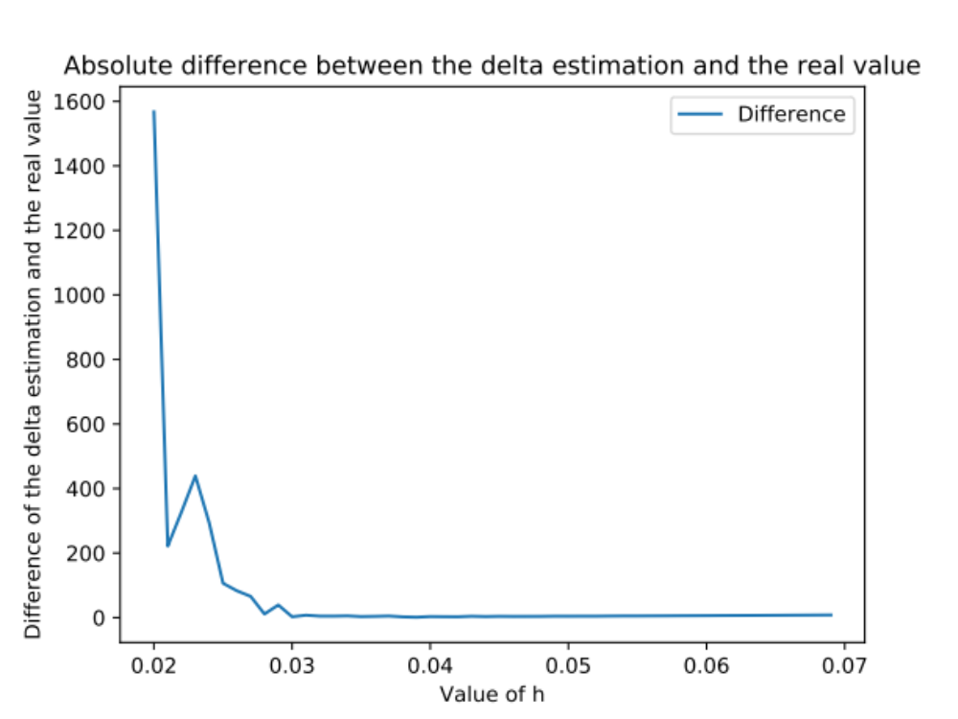
We tried taking h from 0.02 to 0.07 with 50 different step sizes between. Then we observe that the lowest point is near 0.03, therefore we enlarge that part.
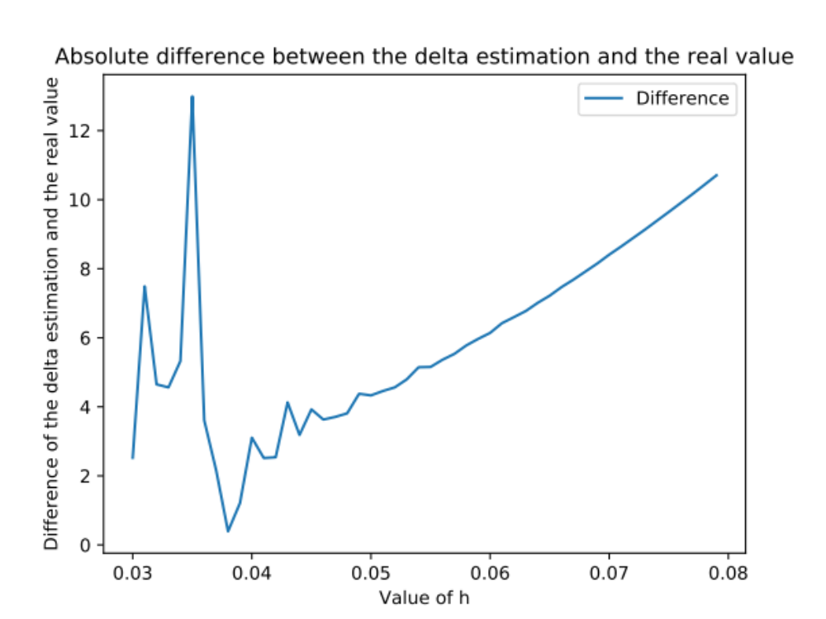
The curve climbs up after 0.05 therefore we enlarge it again
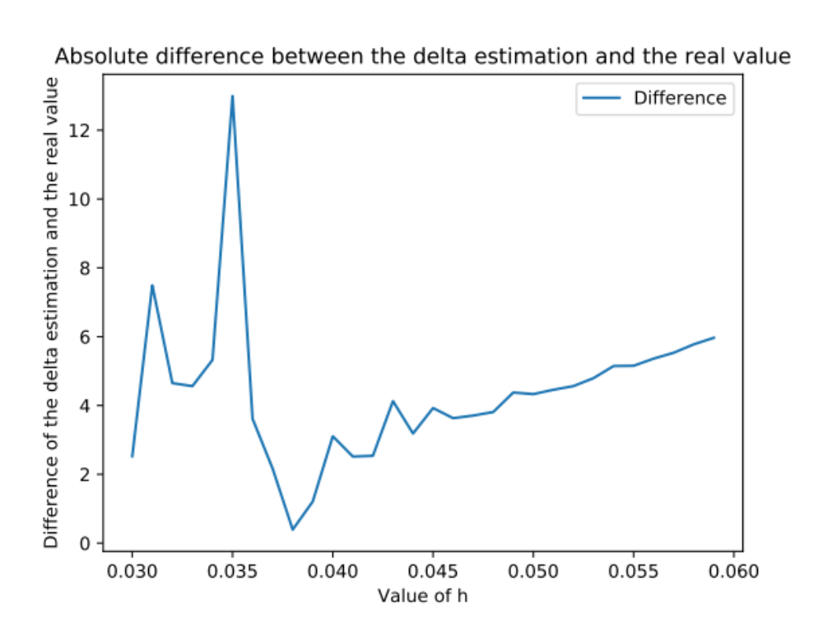
Finally we see that at point at h = 0.038 is the minimum and from the calculation, we have 1024.391987282817 as the result.
Overall we can see that as mentioned in the text, it doesn't really improve the performance of the central difference formula by simply increasing or decreasing the step size. Actually choosing a correct step size is more critical to the result of estimation. In this lab we discovered that we spent about 5 minutes to find out a more accurate step size. But the outcome is still far away comparing to the Cauchy derivative formula. Therefore we think the latter is more preferred for quick choice, but it is possible for us to reach a more accurate estimation by testing for more decimal places of the step size for the central difference formula.

